## **CSC220 – Programming with Java**

## **Assignment 1**

## Part 1 - System Setup

In order to program in Java you will need to have access to the Java Development Kit (JDK) and an Integrated Development Environment (IDE). If you are using your own computer, set up your JDK and IDE using the following information:

## Java JDK

The **Java** Development Kit (**JDK**) is a software development environment used for developing **Java** applications and applets. It includes the **Java** Runtime Environment (JRE), an interpreter/loader (**java**), a compiler (javac), an archiver (jar), a documentation generator (javadoc) and other tools needed in **Java** development. If you will be using your own computer instead of a YC computer, you will need to download and install this on your own computer.

This is a link to the software for JDK:

<https://www.oracle.com/technetwork/java/javase/downloads/index.html>

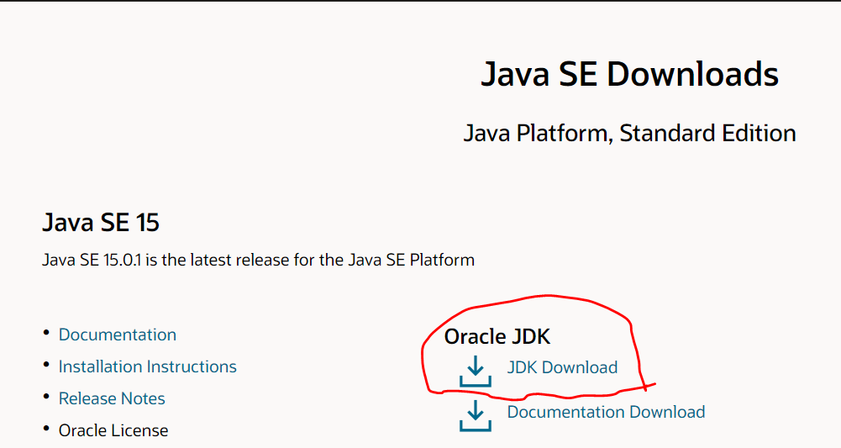

## Netbeans

NetBeans is an **open**-source integrated development environment (IDE) for developing with Java, PHP, C++, and other programming languages. NetBeans is also referred to as a platform of modular components used for developing Java desktop applications. If you will be using your own computer instead of a YC computer, you will need to download and install this on your own computer. Note, there are other IDE’s available for developing Java programs, such as Eclipse, IntelliJ, BlueJ and jEdit. You may choose your preferred IDE however I will be using Netbeans as the standard for the course.

This is a link to the software for Netbeans:

<https://netbeans.apache.org/download/index.html>

Select Apache Netbeans 12:

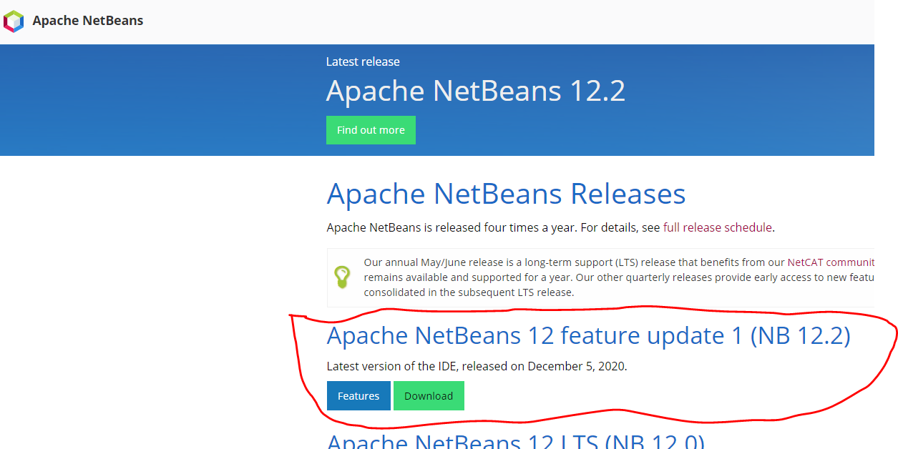

YC has version Apache Netbeans 12.0 installed on its computers

## Part 2 – Writing your first Java Program

The purpose of this part of the assignment is to ensure your development environment is setup correctly and you are ready to write Java programs. (Again, if you are using a YC computer or accessing software vis the YC cloud, you do NOT need to do any software set up. Just proceed with part 2 using YC software.)

Using Netbeans, write your first Java program. The Java program should output:

* your name
* your major
* list any programming experience you have
* your hometown
* your hobbies
* any other interesting information you would like to share with me

Use the video attached to this assignment to complete writing your first program

MY SCREENSHOT

.